Task 1: Working as a Scientist Test

Year 7 Science

Kolbe Catholic College

Name: ________________________

Teacher: _______________________

Mark: ______/42

Materials:

* Pen
* Pencil
* Ruler

You should try to fill all of the available lines when answering written questions. Remember to draw diagrams in pencil with a ruler. No notes or calculator permitted.

Working as a Scientist Test

1. 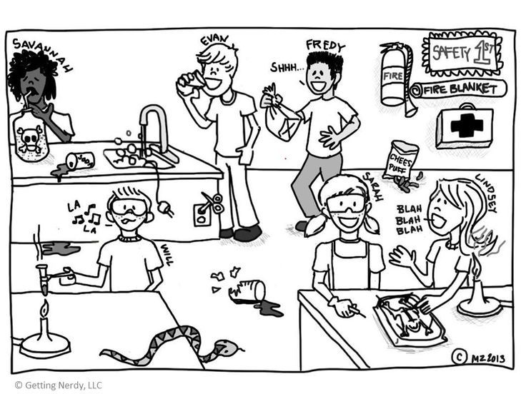Choose two students doing the incorrect thing in the picture below and write their name, what rule they are breaking, and why it is a risk to their safety. (4 marks)
2. _______________________________________________________________________________________________________________________________________________________________________________________________________________________________________________________________
3. _______________________________________________________________________________________________________________________________________________________________________________________________________________________________________________________________

2. Describe the difference between physics and chemistry, giving examples of each. (3 marks)

______________________________________________________________________________________________________________________________________________________________________________

_____________________________________________________________________________________________________________________________________________________________________________________________________________________________________________________________________

For Questions 3-8, circle the correct response. (5 marks)

1. You have been injured in the laboratory, first you should:
   1. Visit Student Reception after class
   2. See a Doctor after school
   3. Tell your Science Teacher
   4. Apply first aid yourself
2. If you do not understand a direction or part of an experiment you should:
   1. Figure it out as you do the experiment
   2. Try different things until something works
   3. Ask the teacher before starting
   4. Skip the step you are unsure of
3. You are heating a beaker and now want to pick it up. You should:
   1. Use a rag or paper towel
   2. Pick up the end that looks cooler
   3. Use a heat-proof glove or tongs
   4. Pour cold water in it so it is cool enough to pick up
4. To change a Bunsen Burner from Safety Flame to Heat Flame you should:
   1. Turn the air hole so it opens
   2. Turn the air hole so it closes
   3. Turn the gas tap so it opens
   4. Turn the gas tap so it closes
5. True of False: Hot glass looks the same as cold glass
   1. True
   2. False
6. True or False: It is okay to leave a Bunsen Burner unattended if it is on Safety Flame
   1. True
   2. False
7. Name the following pieces of Science Equipment and their use (10 marks)

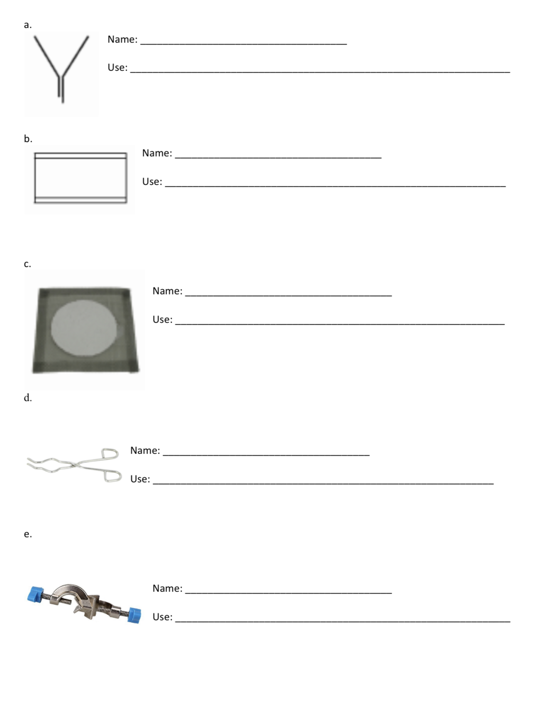

1. Draw a scientific diagram of the following pieces of science equipment. Make sure your drawing takes up the space provided. (4 marks)

|  |  |
| --- | --- |
| 1. Tripod | 1. Conical Flask |
| 1. Clamp | 1. Watch glass |

1. Mr Wheeler needs one coffee everyday to survive year 7 teaching but the electricity is out at Kolbe! Draw a labeled scientific drawing of how he can use science equipment to safely boil water in the science lab. (5 marks)
2. 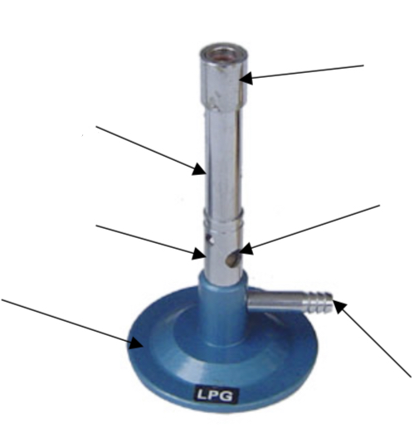Label the parts of the Bunsen Burner below (3 marks)
3. Write the amount of liquid in the measuring cylinders below (2 marks)

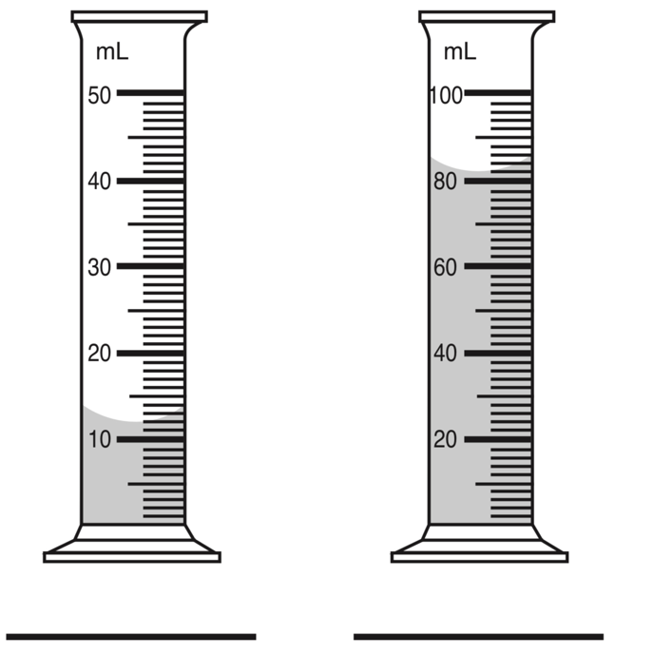

1. Explain the difference between observations and inferences using examples from the image below (6 marks)

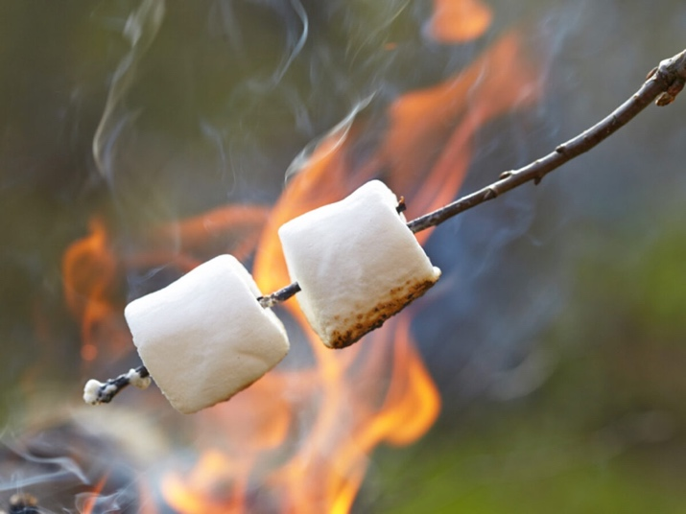

_______________________________________________________________________________________

_______________________________________________________________________________________

_______________________________________________________________________________________

_______________________________________________________________________________________

_______________________________________________________________________________________

_______________________________________________________________________________________

_______________________________________________________________________________________

_______________________________________________________________________________________

_______________________________________________________________________________________

_______________________________________________________________________________________

_______________________________________________________________________________________

_______________________________________________________________________________________

_______________________________________________________________________________________

**END OF TEST**